**Online Forms**

**Version 1.0**



**Group Id: S23027572B (BC180400031)**

**Supervisor Name: Usman Waheed Bhatti**

**Revision History**

|  |  |  |  |
| --- | --- | --- | --- |
| **Date (dd/mm/yyyy)** | **Version** | **Description** | **Author** |
| Current date | 1.0 | Online form application aims to revolutionize the way forms are filled out by providing users with a convenient and user-friendly platform. Say goodbye to the time-consuming process of traditional paperwork and embrace the efficiency of digitized forms. This application offers a seamless experience, making it effortless for users to create and distribute forms while ensuring a high level of usability. By leveraging innovative features and modern design principles, we strive to enhance productivity and simplify the form-filling process. | Bc180400031 |

**Table of Contents**

1. Introduction of Design Document
2. Data Flow Diagram (DFD)
3. Entity Relationship Diagram (ERD)
4. Database Design
5. Interface Design

1. Introduction of Design Document

In the design document, we have comprehensively outlined the details and specifications of our online form application. The document includes a thorough introduction, clearly articulating the purpose and objectives of the application, with a focus on streamlining and digitizing the form-filling process for enhanced convenience.

Additionally, we have meticulously documented the functional requirements of the application, encompassing crucial aspects such as secure login mechanisms, the ability to create diverse forms with multiple question types, setting time limits for form submissions, and establishing a robust data storage system for storing and retrieving responses. The document also stipulates the maximum limits for form and question creation, as well as the provision for accessing the results in a structured Excel sheet format.

The benefits derived from the design document phase in a software development project are manifold:

**Effective Communication:** The design document serves as a vital communication tool, facilitating clear and concise information exchange among the development team, stakeholders, and clients. It ensures that all parties possess a shared understanding of the project's objectives, features, and functionalities.

**Requirement Alignment:** By explicitly defining the functional and non-functional requirements, the design document guarantees the alignment between the development team's understanding and the project's desired specifications. It serves as a reference point to ensure accurate implementation.

**Scope Definition:** The document effectively establishes the project's boundaries and limitations, explicitly outlining the included features, functionalities, and dependencies. By defining the project scope, it aids in managing expectations and minimizing scope creep during the development lifecycle.

**Development Blueprint**: Acting as a comprehensive blueprint, the design document provides a systematic representation of the application's structure, system architecture, and data model. This facilitates the developers' understanding of component interactions, data storage mechanisms, and overall system behavior.

**Collaboration and Feedback**: The design document fosters collaborative efforts among stakeholders, clients, and the development team. It serves as a starting point for productive discussions and feedback, enabling iterative improvements and refinements to the design prior to development commencement.

In summary, the primary purpose of the design document phase within a software development project is to establish a shared understanding of the project's objectives and requirements, clearly define the project scope, and create a comprehensive blueprint to guide the development process. It facilitates effective communication, requirement alignment, risk mitigation, and collaborative refinement, ensuring a well-structured and successful software project execution.

1. Data Flow Diagram (DFD)

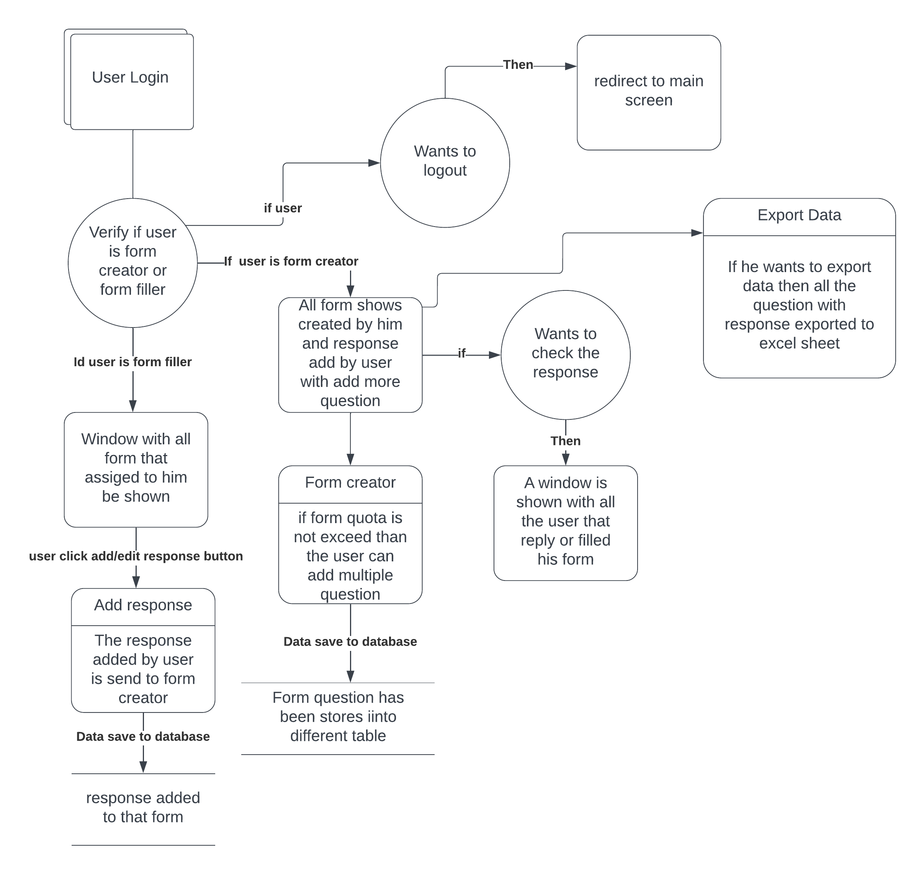

1. Entity Relationship Diagram (ERD)

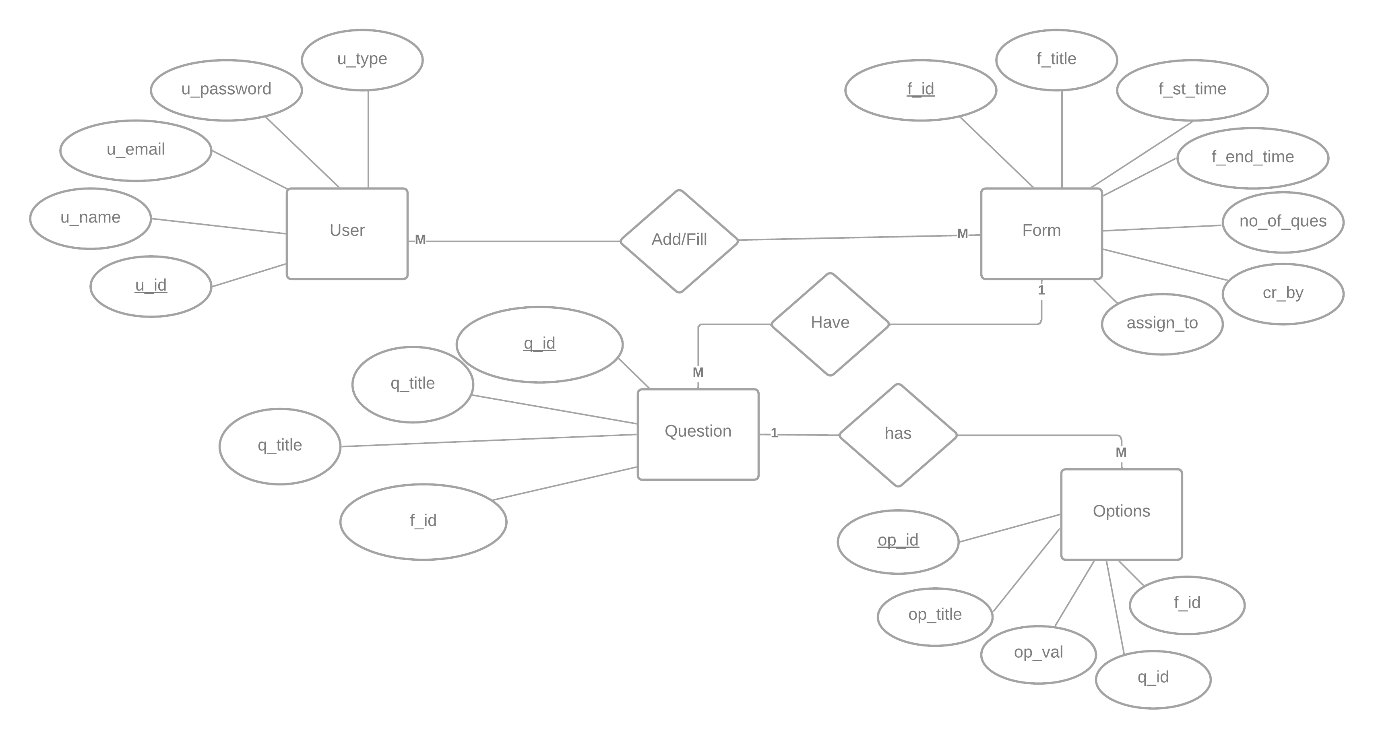

1. Database Design

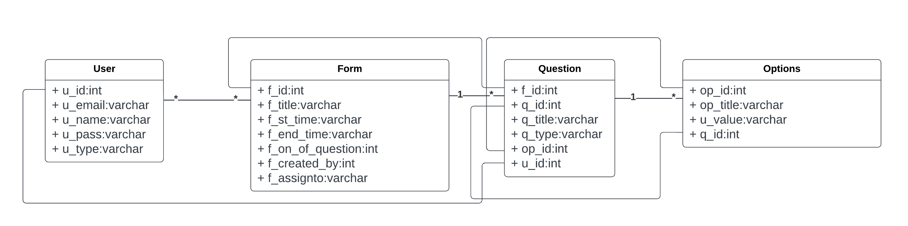

1. Interface Design (Optional)

